  

**MATHEMATICS**

**Specialist Units 3 & 4**

**Test 1 – Complex Numbers**

**Chapters 13, 14 and 15**

**Semester 1 2019**

# 

**Section Two – Calculator Assumed**

Time allowed for this section

Working time for this section: 33 minutes

Marks available: 33 marks

## Material required/recommended for this section

##### To be provided by the supervisor

This Question/Answer booklet

Formula sheet

##### To be provided by the candidate

Standard items: pens, pencils, pencil sharpener, eraser, correction fluid, ruler, highlighters

Special items: drawing instruments, templates, notes on one unfolded sheet of A4 paper, and up to three calculators satisfying the conditions set by the Curriculum Council for this course.

## Important note to candidates

No other items may be used in this section of the examination. It is **your** responsibility to ensure that you do not have any unauthorised notes or other items of a non-personal nature in the examination room. If you have any unauthorised material with you, hand it to the supervisor **before** reading any further.

1. (6 marks)  
   Consider the complex equations $\left|z+3-2i\right|=3$ and $\left|z\right|=\left|z+4-2i\right|$
2. On the set of axes below sketch the graphs of these complex equations [4]

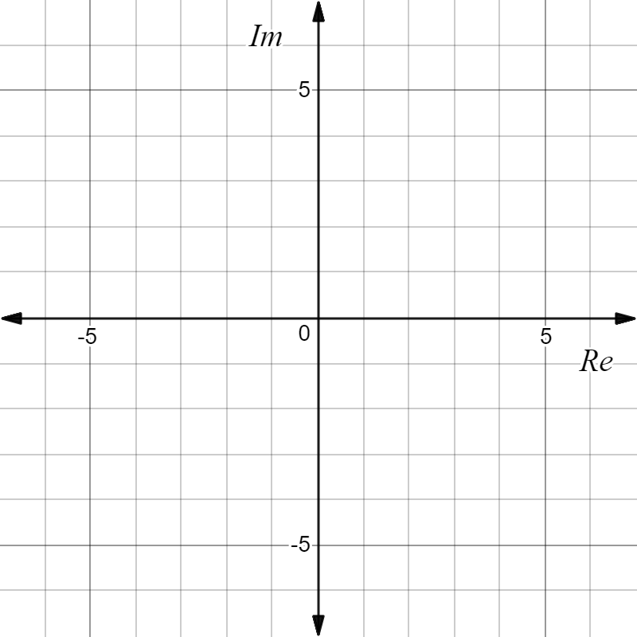

1. On your diagram shade in the region which satisfies [2]

$\left|z+3-2i\right|≤3 ∩ \left|z\right|>\left|z+4-2i\right|$

1. (7 marks)  
   Given $h\left(z\right)=z^{7}+iz^{4}-9iz^{3}+9$
2. Show that $h\left(z\right)=(z^{4}-9i)(z^{3}+i)$ [1]
3. Hence find all solutions to the equation $h\left(z\right)=0$ expressing your answers in the form $rcisθ$ where $r≥0$ and $-π<θ≤π$. [6]
4. (7 marks)  
   A subset of points $z$ in the complex plane form a circle with centre C and radius 4 units as shown.

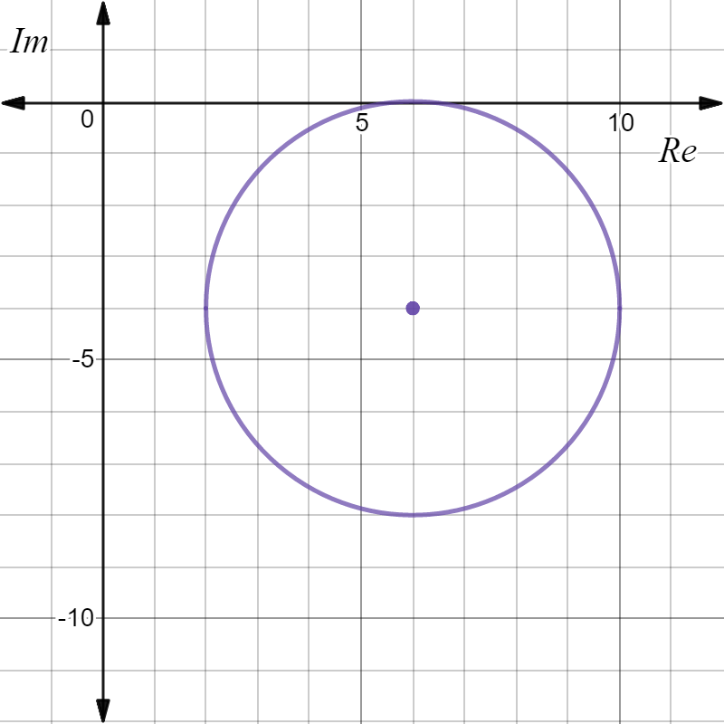

**C**

1. Mark the position on the plane where $\left|z\right|$ is a minimum, clearly label this point A and give this minimum value exactly. [2]

1. Mark the position on the plane where $\left|z+6i\right|$ is a maximum, clearly label this point B and give this maximum value exactly. [2]

1. Determine, to three decimal places, the minimum value of $θ=arg\left(z\right), -π<θ≤π$. [3]

1. (6 marks)  
   If $u=rcisθ , r>0 , -π<θ≤π$ and $w=1+\sqrt{3}i$ express each of the following in terms of $r$ and $θ$.
2. $-u$ [2]
3. $uw$ [2]
4. $\frac{i\overline{u}}{w}$ [2]
5. (7 marks)  
   Assume $x=cisθ$.
6. Use De Moivre’s theorem to prove that $x^{k}-$ $\frac{1}{x^{k}}$ $=2isin(kθ)$ [3]
7. Expand ${\left(x-\frac{1}{x} \right)}^{3}$ and use the outcome in part (a) above to prove that

$3sinθ-4\sin^{3}θ=sin3θ$. [4]

**End of Test**

**This page has intentionally been left blank**

You may use this space to extend or re-attempt an answer to a question or questions and should you do so then number the question(s) attempted and cross out any previous unwanted working.